1. A wire of Nichrome (a nickel–chromium–iron alloy commonly used in heating elements) is 1.0 m long and 1.0 mm2 in cross-sectional area. It carries a current of 4.0 A when a 2.0 V potential difference is applied between its ends. Calculate the conductivity s of Nichrome. •

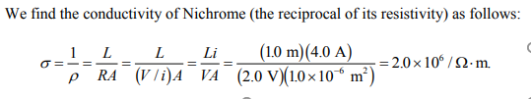

(2) A wire 4.00 m long and 6.00 mm in diameter has a resistance of

15.0 mΩ . A potential difference of 23.0 V is applied between the

ends.

(a) What is the current in the wire? (b) What is the magnitude of the

current density? (c) Calculate the resistivity of the wire material.

(d) Using Table 26.1 identify the material. •

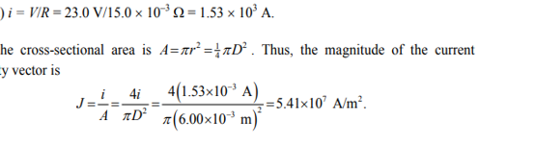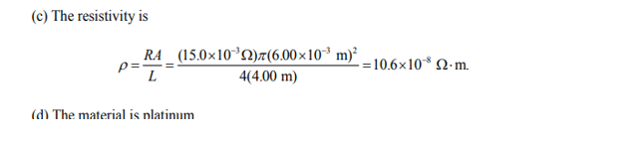

(3)What is the resistivity of a wire of 1.0 mm diameter, 2.0 m length,

and 50Ω resistance?

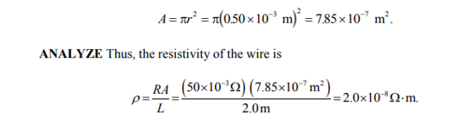

(4) A common flashlight bulb is rated at 0.30 A and 2.9 V (the values of

the current and voltage under operating conditions). If the resistance

of the tungsten bulb filament at room temperature (20/C) is 1.1 Ω ,

what is the temperature of the filament when the bulb is on?

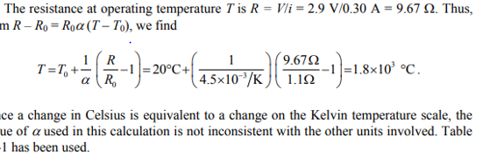

(5) When 115 V is applied across a wire that is 10 m long and has a 0.30 mm radius, the magnitude of the current density is 1.4 x 108 A/m2 .

Find the resistivity of the wire. 